TrustDento
How to Register as a Dentist or Clinic
A complete, step-by-step walkthrough of the sign-up and profile setup process
Prepared from the TrustDento platform source code

Overview
TrustDento is a dentist and dental-clinic directory and booking platform. Dentists and clinic owners register as free members, complete a guided profile setup ("onboarding wizard"), and submit their profile for review. Once a Super Admin approves the profile, it goes live and becomes searchable and bookable by patients.
This guide walks through the entire registration journey end to end, in the order a dentist or clinic owner actually experiences it:
- Create a free account and choose the "Dentist" or "Clinic" role.
- Sign in with Google (the only sign-up method currently offered).
- Complete the 6-step onboarding wizard: Your Details, Your Clinic, Services & Fees, Availability, Gallery & Trust, and Review & Submit.
- Submit the profile for admin review and wait for approval.
Note: Screenshots in this guide are accurate visual reconstructions of the actual registration screens, built directly from the platform's own templates, stylesheet and logic (not a live demo environment), so every field, label, option and layout matches what a real dentist or clinic owner sees.

Step 1 — Create a Free Account
Registration starts at the "Create Your Free Account" page. There is no separate registration form for name/email/password — TrustDento currently only supports account creation through Google Sign-In.
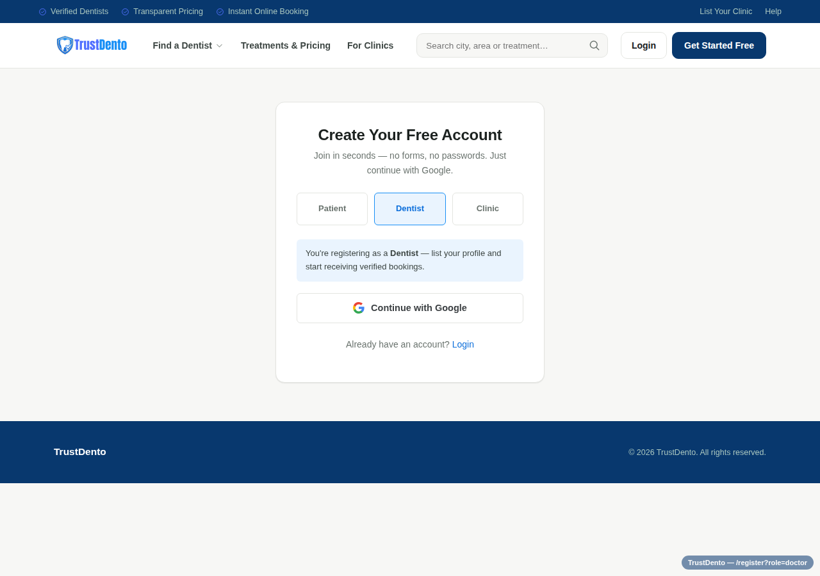
The account creation screen, with "Dentist" selected as the role

What to do on this screen
- Go to the registration page (reachable from "Get Started Free", "List Your Clinic", "For Clinics", or "Register as a Doctor" in the site menu).
- At the top, choose the role tab that matches you: Patient, Dentist, or Clinic. A dentist registering individually should choose Dentist; someone registering on behalf of a clinic/practice should choose Clinic. Both roles lead into the same onboarding wizard afterward.
- A short note confirms the chosen role, e.g. "You're registering as a Dentist — list your profile and start receiving verified bookings."
- Click Continue with Google and sign in with the Google account you want tied to your TrustDento profile.
Note: If Google Sign-In isn't configured on a given deployment, the page shows an error asking the person to contact support instead — there is currently no email/password fallback for new accounts.
After Google confirms the identity, TrustDento either logs into an existing matching account, or — for a brand-new email — creates a new account with the role chosen on this screen (Dentist or Clinic). Either way, a Dentist or Clinic Owner account is sent straight into the onboarding wizard next.

Step 2 — The Onboarding Wizard
Every new Dentist or Clinic Owner account is redirected to /doctor/onboarding immediately after signing in. This is a single guided form split into 6 steps, with a progress bar at the top and Back / Continue buttons at the bottom of each step. Nothing goes live yet — the wizard only builds up the profile that gets submitted for review at the very end.
The 6 steps are: Your Details, Your Clinic, Services & Fees, Availability, Gallery & Trust, and Review.

2.1 — Your Details
The first step collects information about the dentist personally.
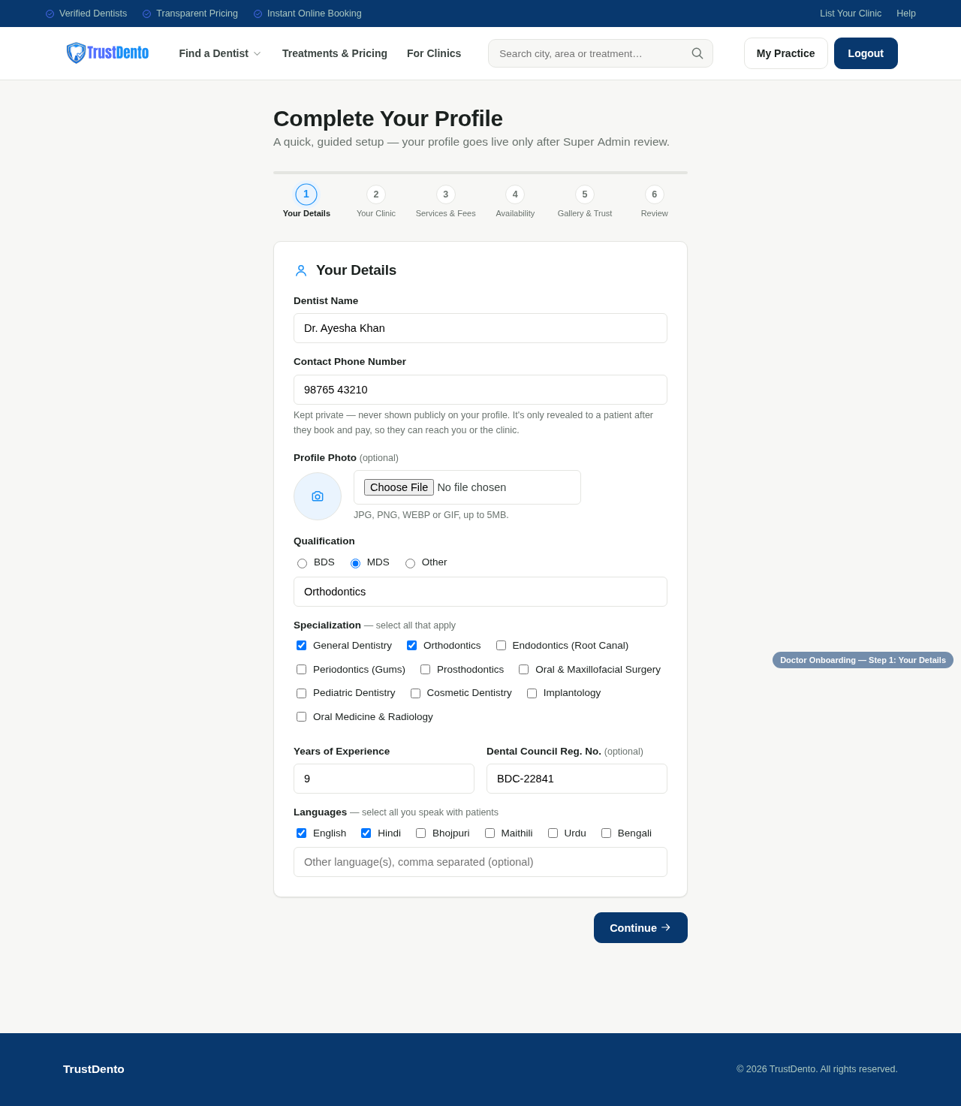
Step 1 of the wizard — Your Details
- Dentist Name — required.
- Contact Phone Number — required. This is kept private and is only shared with a patient after they book and pay.
- Profile Photo — optional. JPG, PNG, WEBP or GIF, up to 5MB.
- Qualification — required. Choose BDS, MDS or Other, with an optional free-text detail field (e.g. "Orthodontics").
- Specialization — optional, multi-select (General Dentistry, Orthodontics, Endodontics, Periodontics, Prosthodontics, Oral & Maxillofacial Surgery, Pediatric Dentistry, Cosmetic Dentistry, Implantology, Oral Medicine & Radiology).
- Years of Experience — required, numeric.
- Dental Council Registration No. — optional.
- Languages — optional, multi-select (English, Hindi, Bhojpuri, Maithili, Urdu, Bengali), plus a free-text "Other languages" field.
Click Continue to move to the next step.

2.2 — Your Clinic
Every dentist profile must be linked to a clinic. This step offers two modes, toggled at the top:
- Set up a new clinic — for a dentist/clinic owner whose clinic is not yet listed on TrustDento.
- Link to an existing clinic — for a dentist who works at a clinic that is already on the platform; they search for it by name and select it, and an admin later confirms the association before the profile is approved.
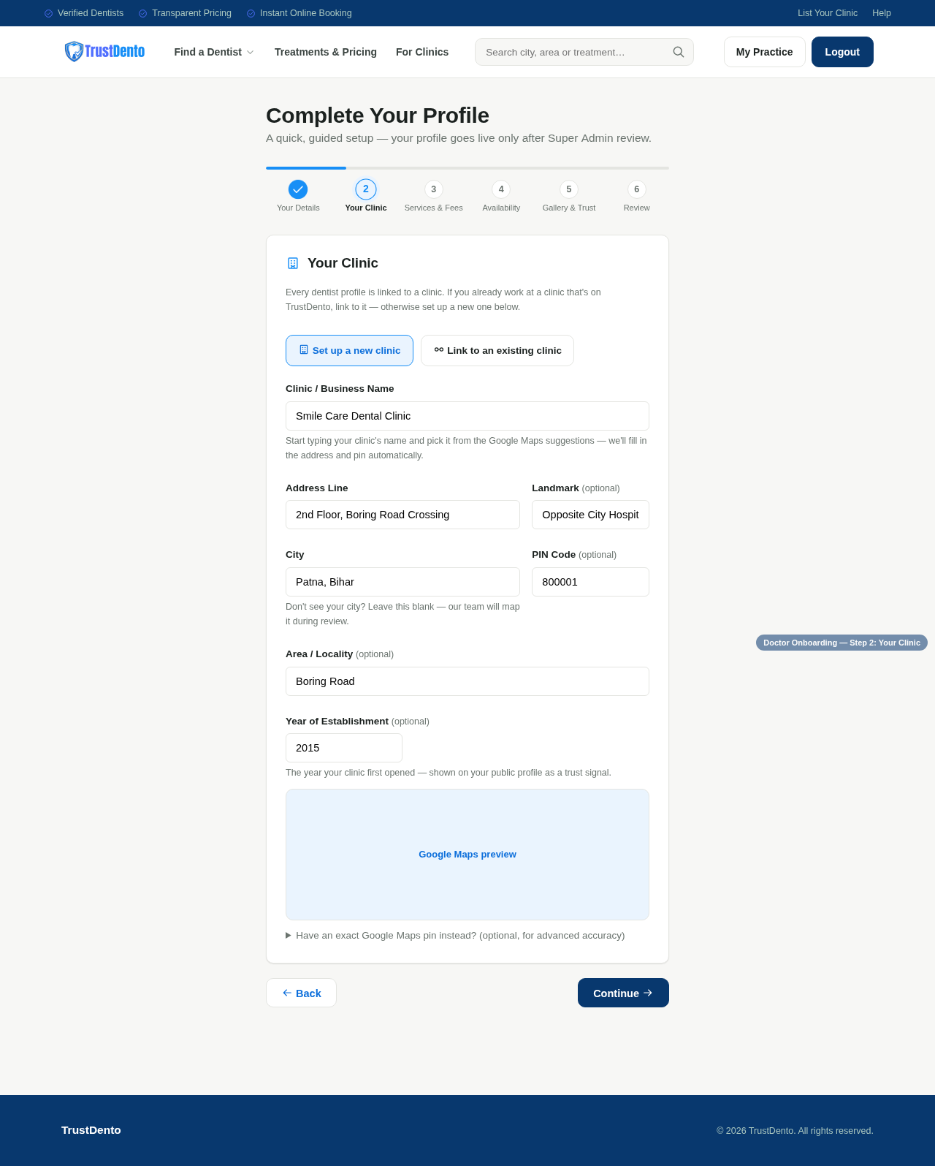
Step 2 of the wizard — Your Clinic (Set up a new clinic mode)
When setting up a new clinic, the following fields are captured:
- Clinic / Business Name — with Google Maps-powered autosuggest when Places is enabled, to auto-fill address and location.
- Address Line and Landmark (landmark optional).
- City — searchable; if the city isn't found, it can be left blank for the TrustDento team to map during review.
- PIN Code — optional, 6 digits.
- Area / Locality — optional, only searchable once a City is chosen.
- Year of Establishment — optional, shown publicly as a trust signal.
- A live map preview of the pinned location.
- An optional Google Maps share-link field for pinpoint accuracy, found via Google Maps → Share → Copy link.
Click Continue to move to the next step.

2.3 — Services & Fees
This step sets the consultation fee and, optionally, the specific treatments offered with price ranges.
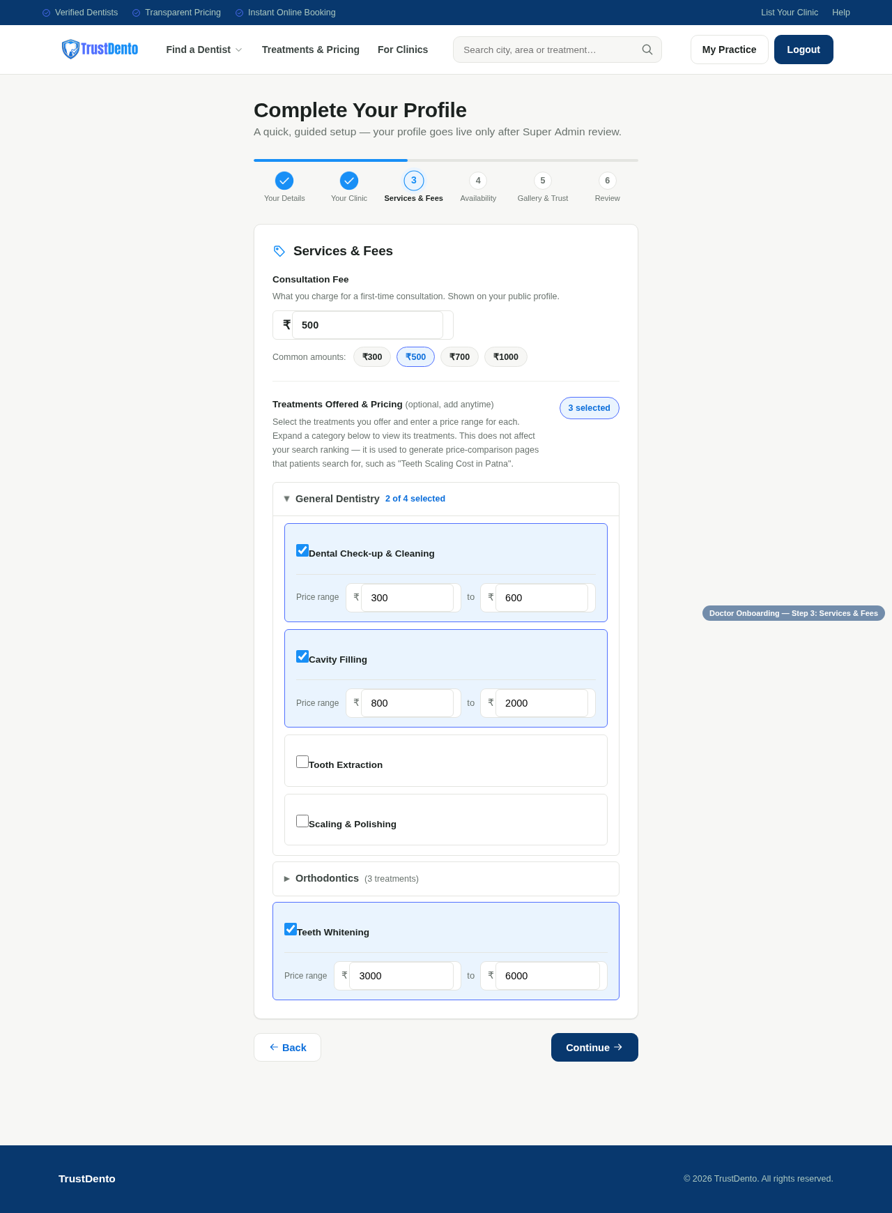
Step 3 of the wizard — Services & Fees
- Consultation Fee — required. What is charged for a first-time consultation; shown publicly. Quick-select chips are offered for common amounts (₹300 / ₹500 / ₹700 / ₹1000).
- Treatments Offered & Pricing — optional and can be added at any time later. Treatments are grouped into expandable categories (e.g. "General Dentistry", "Orthodontics"); checking a treatment reveals a Min–Max price range field for it.
Note: Selecting treatments does not affect search ranking. It is used to power TrustDento's treatment price-comparison pages, e.g. "Teeth Scaling Cost in [City]".
Click Continue to move to the next step.

2.4 — Availability
This step sets the weekly booking schedule, using one of two modes:
- Single Timeframe — one set of days, one start/end time, and one appointment length applied uniformly across all checked days. Simplest option for a practice with the same hours every working day.
- Multiple Timeframe — day-by-day control, allowing different hours (and even multiple shifts, e.g. morning and evening) for each day of the week.
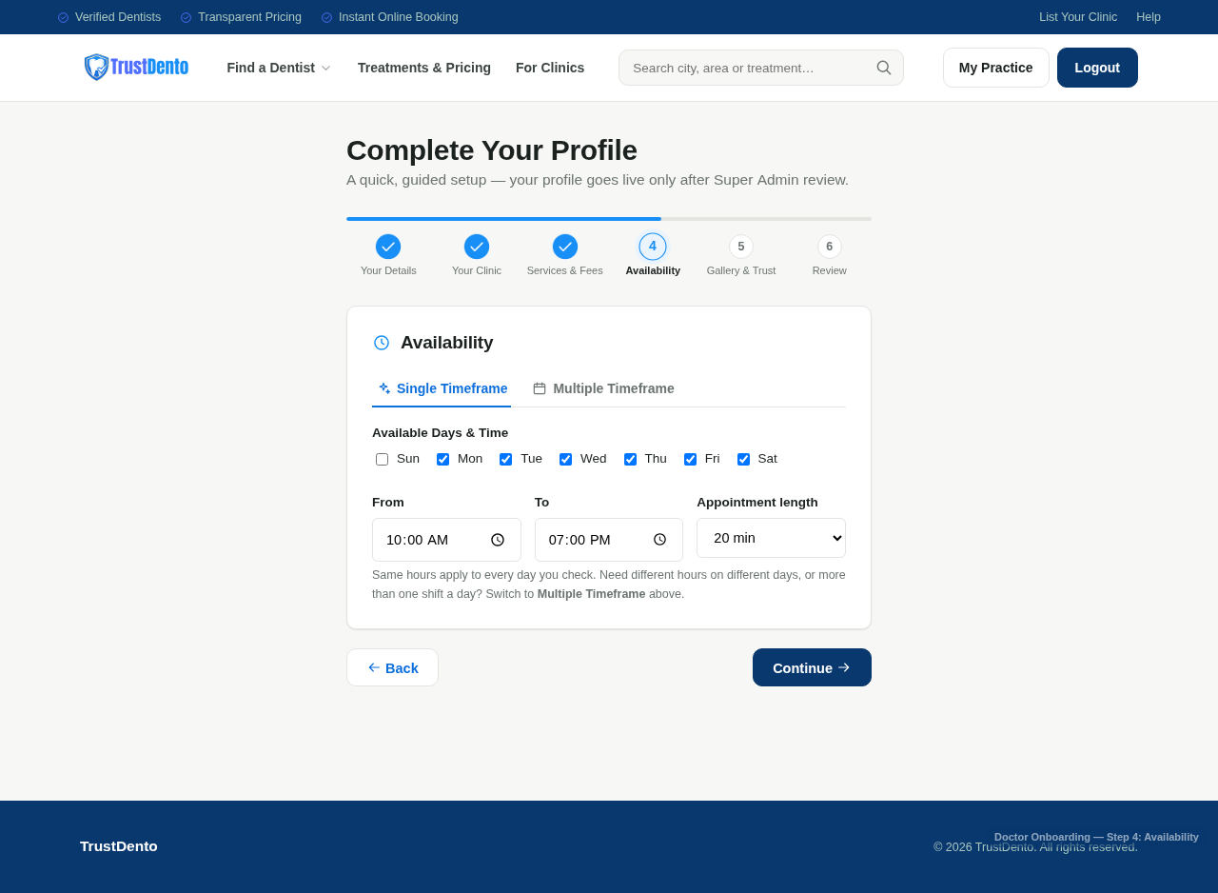
Step 4 of the wizard — Availability (Single Timeframe mode)
- Available Days — a checkbox row for Sun through Sat.
- From / To time — the daily working window (Single Timeframe mode).
- Appointment length — 10, 15, 20, 30, 45 or 60 minutes; this determines how bookable slots are generated.
Click Continue to move to the next step.

2.5 — Gallery & Trust
This step is entirely optional but strongly recommended — clinic photos are one of the biggest trust signals shown to prospective patients.
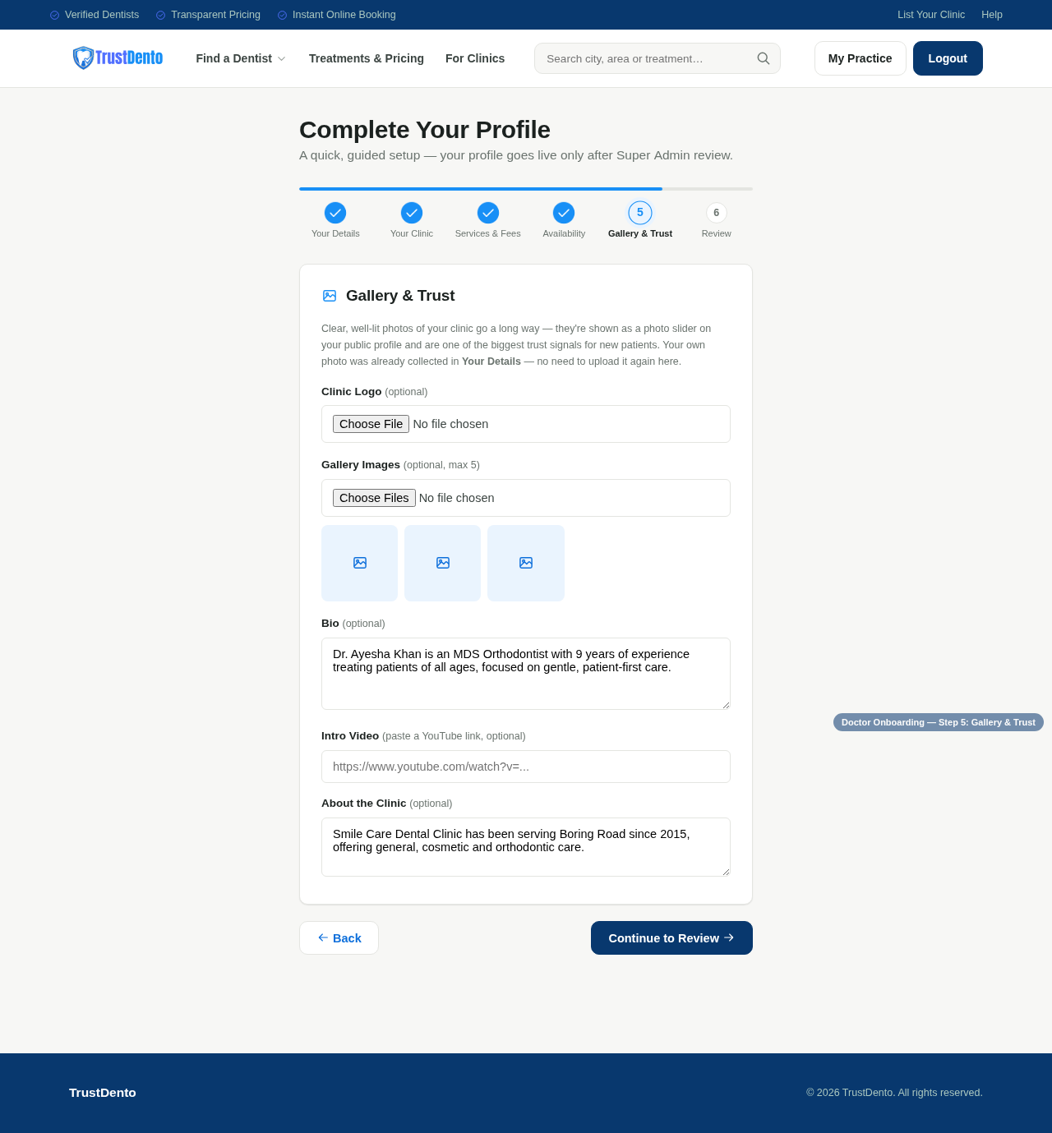
Step 5 of the wizard — Gallery & Trust
- Clinic Logo — optional image upload.
- Gallery Images — optional, up to 5 photos, shown as a photo slider on the public profile.
- Bio — optional free-text about the dentist.
- Intro Video — optional YouTube link.
- About the Clinic — optional free-text description of the clinic.
Click Continue to Review to move to the final step.

2.6 — Review & Submit
The final step shows a read-only summary of everything entered across all five previous steps, grouped by section, so it can be double-checked before submission.
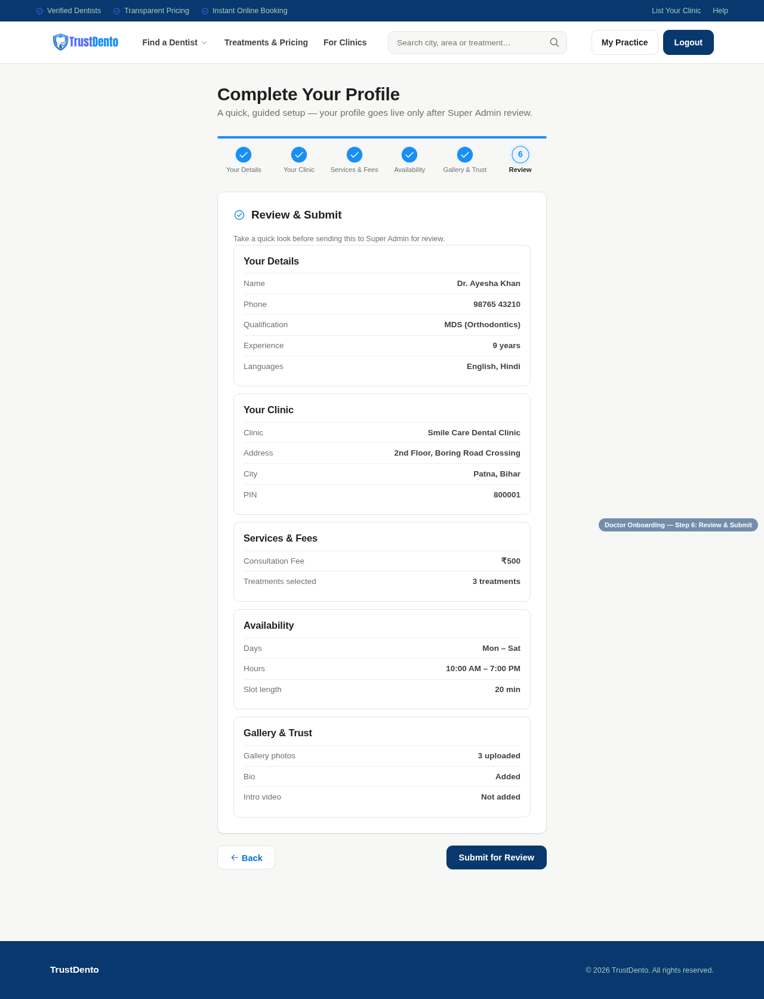
Step 6 of the wizard — Review & Submit
Clicking Submit for Review sends the completed profile to TrustDento's Super Admin queue. At this point the dentist can use Back to correct anything in an earlier step before submitting.

Step 3 — After Submitting: Awaiting Approval
Once submitted, the dentist/clinic profile status is set to Pending Review. The profile is not yet visible to patients and cannot be booked. The dentist is returned to their My Practice dashboard, which now shows the pending status clearly.
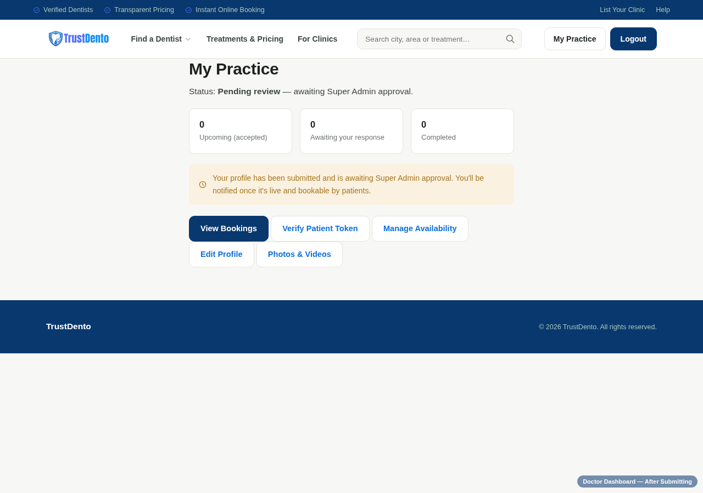
The My Practice dashboard, showing "Pending review" status right after submission
From this dashboard, a dentist can, at any time:
- Edit Profile — return to the onboarding wizard to update any information (re-submits for review).
- Manage Availability — adjust the weekly schedule directly, without re-entering the full wizard.
- Photos & Videos — manage gallery images and videos separately from the wizard.
- View Bookings / Verify Patient Token — used once the profile is live and approved.
Note: If a Super Admin rejects a submission, the dashboard instead shows the rejection reason along with an "Update & resubmit" link back into the wizard. Once approved, the status changes to Approved and the profile becomes live, searchable, and bookable by patients.

Quick Summary
- Go to Register, choose Dentist or Clinic, and continue with Google.
- Complete Step 1: Your Details (name, phone, photo, qualification, specialization, experience, languages).
- Complete Step 2: Your Clinic (set up a new clinic, or link to an existing one).
- Complete Step 3: Services & Fees (consultation fee, optional treatment pricing).
- Complete Step 4: Availability (working days, hours, appointment length).
- Complete Step 5: Gallery & Trust (optional photos, bio, video, clinic description).
- Review everything on Step 6 and click Submit for Review.
- Wait for Super Admin approval — the profile then goes live automatically.

